**FORM 316**

*(See* rule 24 )

***Application under sub-section (11) of section 23 for cancellation of assessment order passed under sub-section (2),(3)or (4) of section 23 of the Maharashtra Value Added Tax Act, 2002***

To

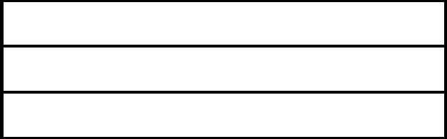

I hereby apply for cancellation of assessment order passed under sub-section (2), (3) or (4) of section 23 of the Maharashtra Value Added Tax Act, 2002 .

Further I state that, I could not attend before you on the last appointed day for assessment . I hereby apply for cancellation of assessment order as provided in sub-section (11)of section 23 of the said Act.

(1) Name of the applicant

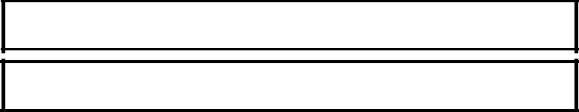

(2) Name and style of business



(3) TIN M.V.A.T. Act, 2002

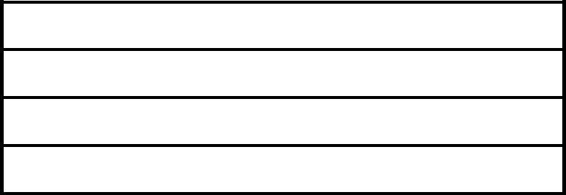

1. TIN under C.S.T. Act, 1956
2. Address of the place of Business
3. The details of the Assessment Order as below.



(i) Period of Assessment



(ii) Date of the Assessment Order



(iii) Date of service of the Assessment Order

You are requested to cancel by order the above said assessment order including any penalty or interest levied in relation to or in consequence to the said assessment .

Date



Place



Yours faithfully



Signature and Status of the per

Received application in Form 316 for the period from _______________ to

________________ on _____________ ( date of receipt) in respect of M/s

________________________________________________ Name of dealer ) holding certificate of Registration bearing No. _______________________ and serial No. of the acknowledgement is _____________________________________

as per register No. _______________________.

|  |  |  |
| --- | --- | --- |
| Date |  | Signature |
|  |  | Stamp |
| Place |  | (Assessing Authority) |



( To be detached and given to the dealer or his representative) .

___________________________________________________________________

__________________________